Avishkar Waikar
Cse IS-2

ASSIGNMENT 1

Problem Statement:
Installation and Configuration of machine learning environment with Anaconda on windows or Ubuntu (Jupyter notebook)

Output:



After downloading and installing Anaconda Navigator, we use jupyter notebook for the installation of required libraries.

Creating environment:
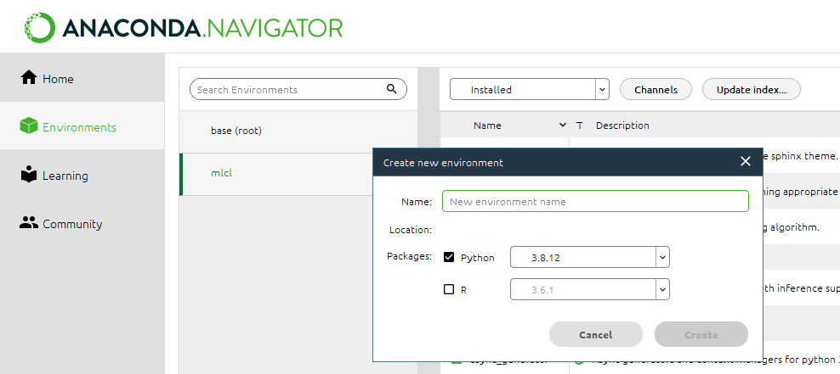

Installing libraries using terminal:

1)Sklearn
Install:
Pip install Sklearn

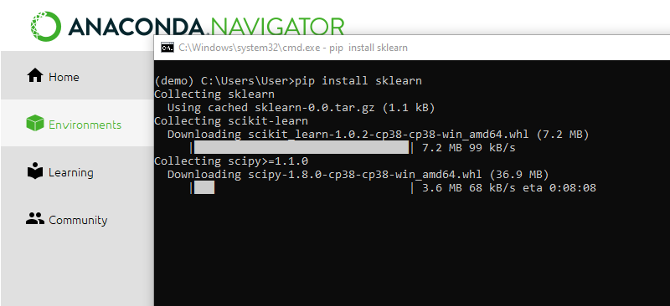

Package Info:
pip show sklearn
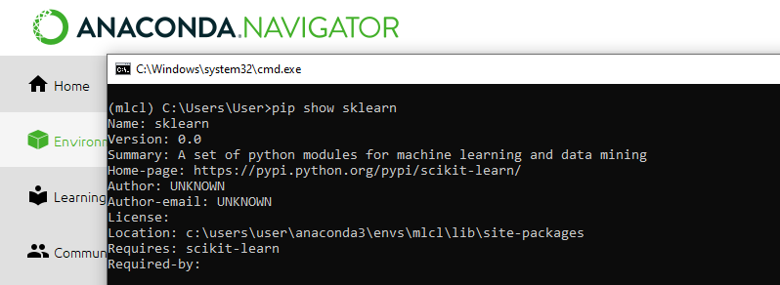

2) Numpy

pip install numpy
pip show numpy

3) PANDAS

pip install pandas
pip show pandas

4) Matplotlib

pip install matplotlib
pip show matplotlib

Conclusion:
Thus we have successfully installed Anaconda on windows; We also have described the libraries and the installation of the libraries.
ASSIGNMENT 2

Problem Statement:
Download any dataset from UCI or Data.org or from any data repositories and perform the basic data pre-processing steps using Python/R

Theory:

Data cleaning: The main aim of Data Cleaning is to identify and remove errors & duplicate data, in order to create a reliable dataset. This improves the quality of the training data for analytics and enables accurate decision-making.

Normalization: Normalization is a scaling technique in which values are shifted and rescaled so that they end up ranging between 0 and 1. It is also known as Min-Max scaling.

Standardisation:
The ultimate goal to perform standardization is to bring down all the features to a common scale without distorting the differences in the range of the values.

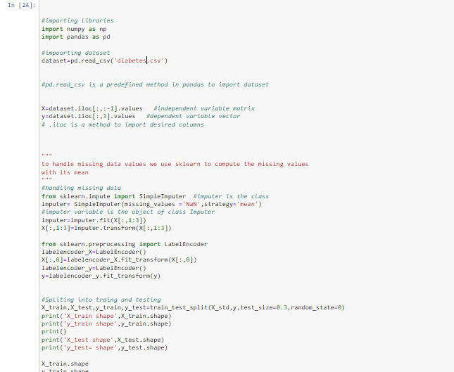
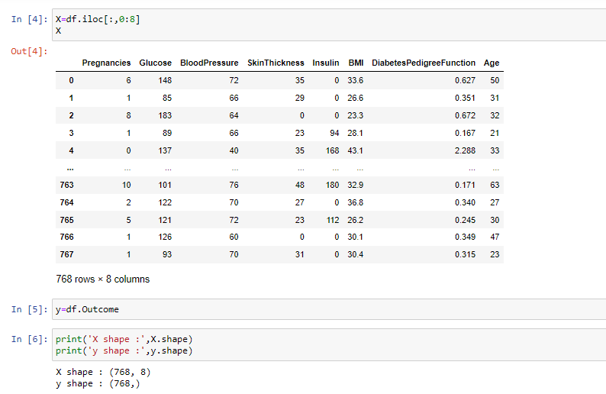
Conclusion: Thus we have successfully implemented pre-processing operations on a dataset
ASSIGNMENT 3

Problem Statement:
Download the any dataset from UCI or Data.org or from any other data repositories and Implement Single and multilayer perceptron on a dataset

Theory:

Regression:
Regression algorithms are used to predict the continuous values such as price, salary, age.

Classification:
Classification algorithms are used to predict/Classify the discrete values such as Male or Female, True or False, Spam or Not Spam

Multilayer Perceptron:
In the Multilayer perceptron, there can be more than one linear layer (combinations of neurons). If we take the simple example of the three-layer network, the first layer will be the input layer and last will be the output layer and the middle layer will be called the hidden layer. We feed our input data into the input layer and take the output from the output layer. We can increase the number of the hidden layer as much as we want, to make the model more complex according to our task.

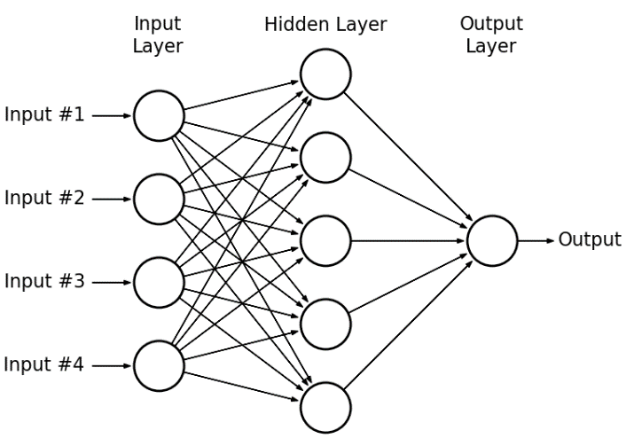

Backpropagation Algorithm:
The algorithm is used to effectively train a neural network through a method called chain rule. In simple terms, after each forward pass through a network, backpropagation performs a backward pass while adjusting the model’s parameters (weights and biases). In other words, backpropagation aims to minimise the cost function by adjusting the network's weights and biases. The level of adjustment is determined by the gradients of the cost function with respect to those parameters.

Activation Function:
Activation functions, also known non- non-linearity, describe the input-output relations in a non-linear way. This gives the model power to be more flexible in describing arbitrary relations. Here are some popular activation functions Sigmoid, Relu, and TanH.

Precision:
Precision is the ratio of correctly predicted positive observations to the total predicted positive observations. The question that this metric answer is of all passengers that are labelled as survived, how many actually survived? High precision relates to the low false positive rate. We have got 0.788 precision which is pretty good.
Precision = TP/TP+FP

F1 score:
F1 Score is the weighted average of Precision and Recall. Therefore, this score takes both false positives and false negatives into account. Intuitively it is not as easy to understand as accuracy, but F1 is usually more useful than accuracy, especially if you have an uneven class distribution. Accuracy works best if false positives and false negatives have similar cost. If the cost of false positives and false negatives are very different, it’s better to look at both Precision and Recall.

Confusion matrix:
The confusion matrix shows the ways in which your classification model is confused when it makes predictions. It gives us insight not only into the errors being made by a classifier but more importantly the types of errors that are being made
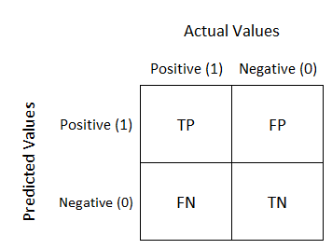

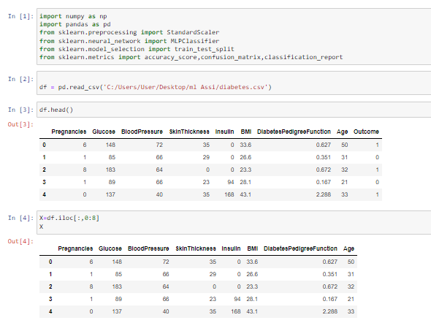
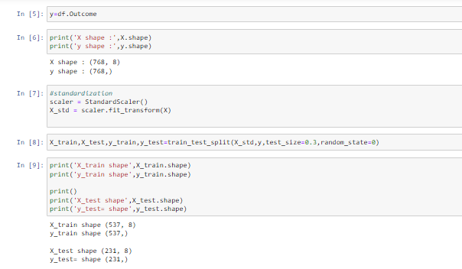
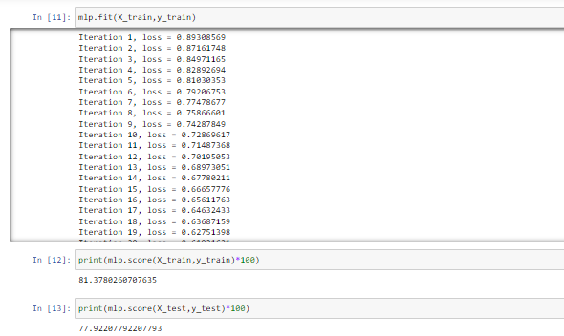
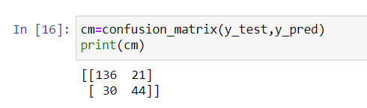

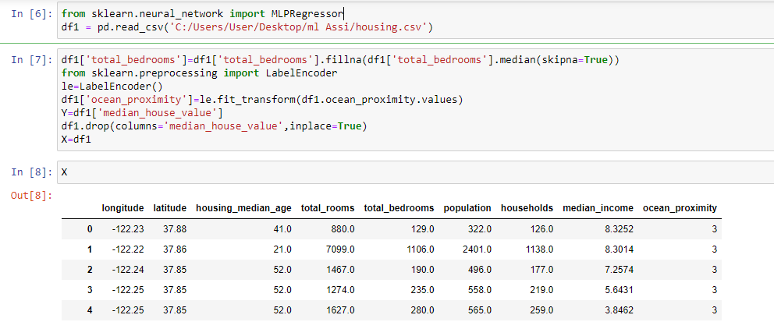
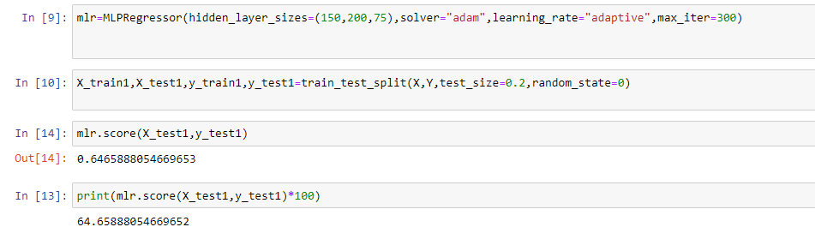

Conclusion:
Thus we have successfully completed the implementation of Multilayer perceptron.

ASSIGNMENT 4

Problem Statement:
Develop a Bayesian classifier

Theory:

Bayes Theorem:
Bayes’ Theorem is a way of finding a probability when we know certain other probabilities.

Naive Bayes:
Naive Bayes algorithm is a supervised learning algorithm, which is based on Bayes theorem and used for solving classification problems.
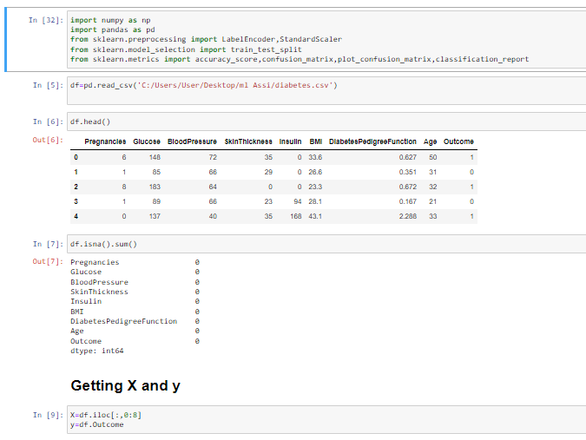
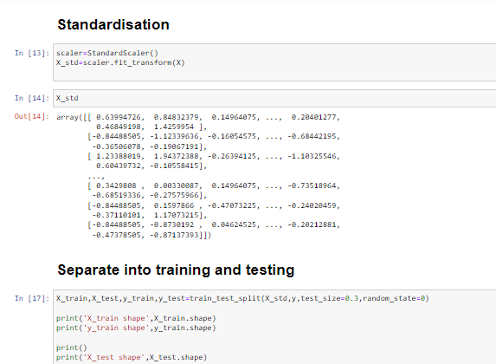
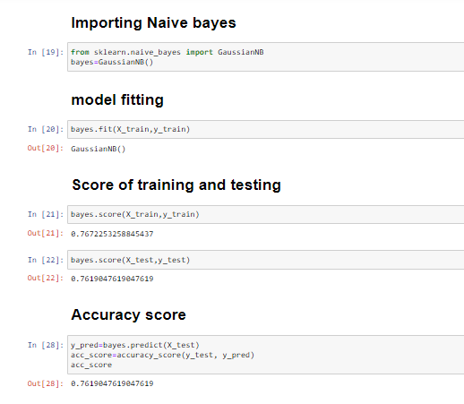
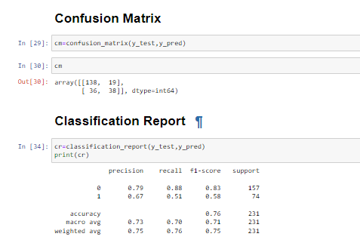
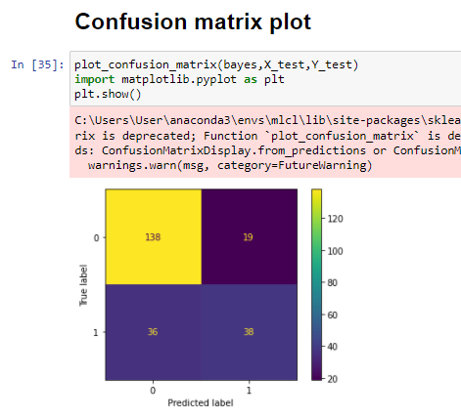

Conclusion:
Thus we have successfully completed the implementation of Naïve Bayes Gaussian Classifier

ASSIGNMENT 5

Problem Statement:
Implement SVM for given dataset

Theory:
SVM:
support-vector machines SVMs, also support-vector networks are supervised learning models with associated learning algorithms that analyse data used for classification and regression analysis.
Given a set of training examples, each marked as belonging to one or the other of two categories, an SVM training algorithm builds a model that assigns new examples to one category or the other, making it a non-probabilistic binary linear classifier (although methods such as Platt scaling exist to use SVM in a probabilistic classification setting).
An SVM model is a representation of the examples as points in space, mapped so that the examples of the separate categories are divided by a clear gap that is as wide as possible. New examples are then mapped into that same space and predicted to belong to a category based on the side of the gap on which they fall. In addition to performing linear classification, SVMs can efficiently perform a non-linear classification using what is called the kernel trick, implicitly mapping their inputs into high-dimensional feature spaces. Kernel function In machine learning, kernel methods are a class of algorithms for pattern analysis, whose best known member is the support vector machine (SVM).
Significance of SVM
it is capable of doing both classification and regression. Non-linear SVM means that the boundary that the algorithm calculates doesn't have to be a straight line. The benefit is that you can capture much more complex relationships between your datapoints without having to perform difficult transformations on your own. The downside is that the training time is much longer as it's much more computationally intensive.
What is the purpose of the support vector in SVM? A support vector machine attempts to find the line that "best" separates two classes of points.

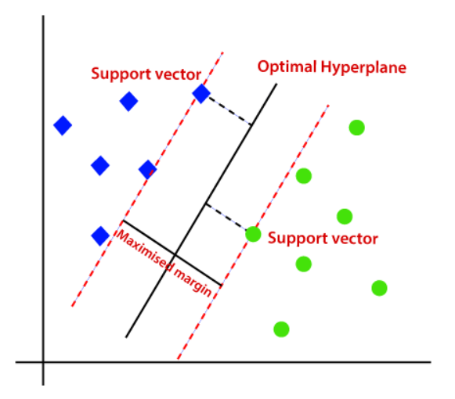

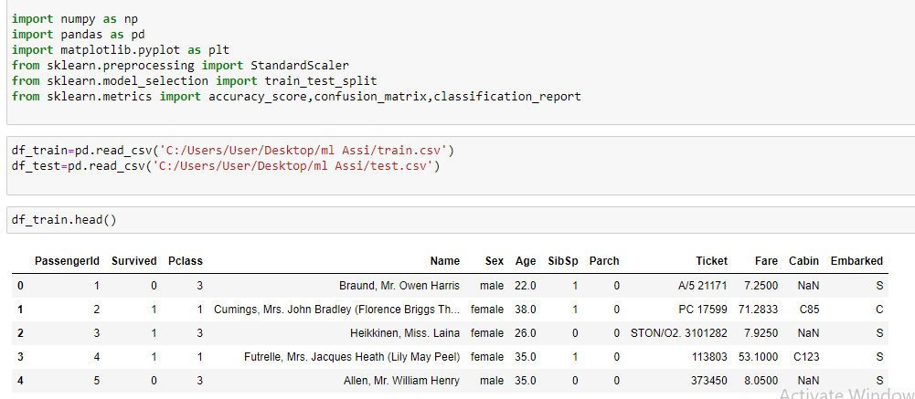
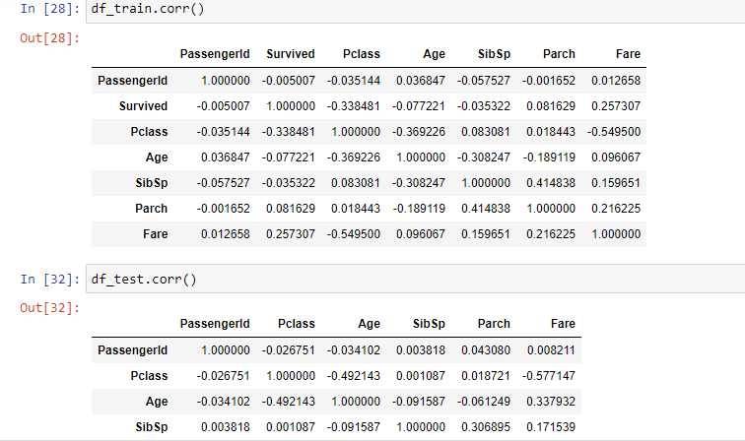
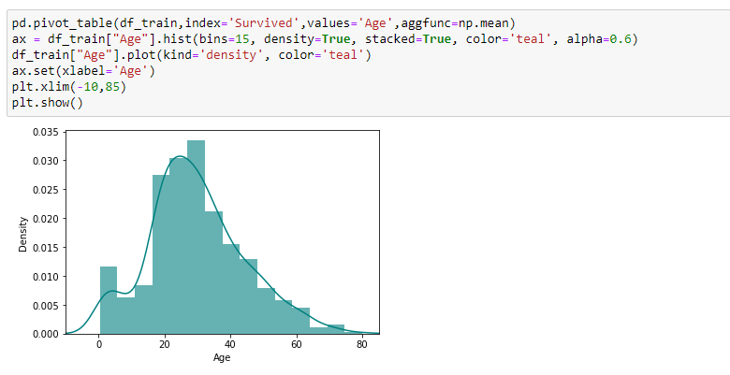
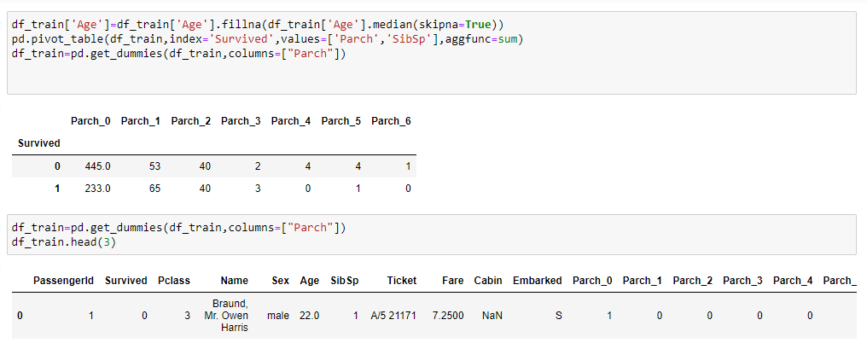
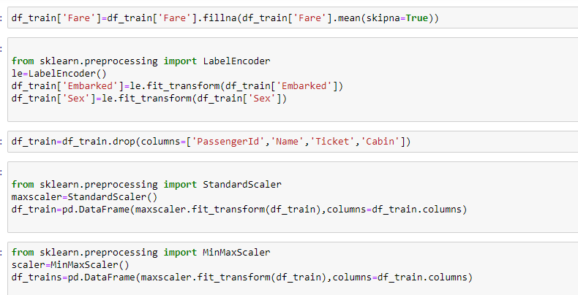
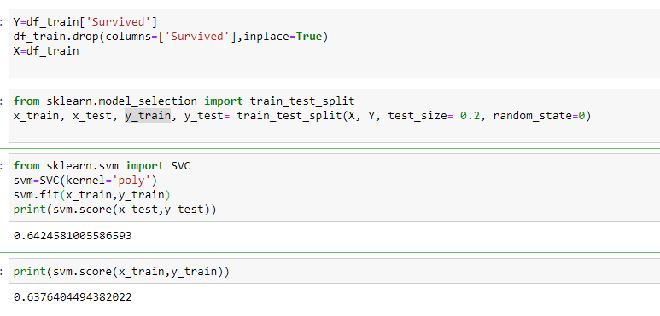

Conclusion:
Svm has been implemented

